1030 West Bay Dr.

Largo, FL 33770

Phone (727)585-2200

Fax (727)584-9239

HIPAA Authorization

We are required to ask anyone requesting information regarding your care for their name(s). Anyone not listed on this form as a person you wish to have access to your health records will be denied their request. I understand that the HIPAA agreement is protecting my right to privacy. I wish to allow the staff at St. Michael’s Eye & Laser Institute and/ or St. Michael’s Surgery Center to disclose my personal healthcare information to the following people.

__________________________________________________________ ___________________________

Name Relationship

__________________________________________________________ ___________________________

Name Relationship

Please read the notice of privacy practices and sign below stating you have received a copy and an opportunity to review it in detail.

Consent to Treat

HIPAA Authorization

During an eye exam, we may dilate your pupils. After dilation, you will be extremely sensitive to the sun and have someone assist you in driving home. Dilation will also interfere with near vision activities (such as reading) for 4 to 12 hours, or longer. If at any point additional treatment outside the scope of general eye care is warranted, an additional consent will be provided outlining the appropriate Risks and Benefits.

This consent is only revocable in writing and is valid for a lifetime. Please inform the office of any medical conditions, medication, and previous procedures on the additional Medical History forms. Accurate history of your condition will help us make the best decisions regarding your care. I hereby give my written consent to the clinical staff of St. Michael’s Eye & Laser Institute and/or Surgery Center for the treatment of my eye care needs.

_________________________________________________________ ___________________________

Patient Signature Date

Authorization to Release Information to Insurance

I hereby give permission to St. Michael’s Eye & Laser Institute (provider) to release information to my insurance company and/or financial institution. I hereby assign payment directly to St. Michael’s Eye & Laser Institute of all benefits applicable and otherwise payable to me. As a courtesy, St. Michael’s Eye & Laser Institute verifies insurance benefits. However, I understand that I am financially responsible to St. Michael’s Eye & Laser Institute and/or Surgery Center for charges not covered by this assignment or for any and all charges which the insurance carrier declines to pay.

_________________________________________________________ ___________________________

Patient Signature Date

1030 West Bay Dr.

Largo, FL 33770

Phone (727)585-2200

Fax (727)584-9239

# Patient Financial Agreement

Patient Name: _________________________________________________ DOB: ______________ Date: ____________

St. Michael’s Eye & Laser Institute along with St. Michael’s Surgery Center pride themselves on providing patients with the information as needed to assess the financial aspect of their eye care needs.

Please remember that insurance is considered a method of reimbursement for fees owed to the doctor and is not a substitute for payment. Some carriers pay fixed allowances for certain procedures, and others pay a percentage of the charges. It is your responsibility to pay any deductible, co-insurance, co-payment, and any other balance not paid for by your insurance. In addition, you are responsible for obtaining any authorization required by your insurance company. If the authorizations are not obtained, the insurance company will deny payment and you will be responsible for payment. In order to control the cost of billing, we request that our charges for the office visits be paid upon arrival of your visit. If payment is not received timely, our office will send your bill to our collections department and you will incur charges for all collections, attorney, and court fees incurred for the collection of your delinquent account.

St. Michael’s Eye & Laser may provide you with your medical records if desired. You may be billed at a rate of $1.00 per page up to 25 pages, then $.25 for each additional page.

1. I request payment of authorized Medicare and/or insurance benefits be made to St. Michael’s Eye and Laser Institute and/ or St. Michael’s Surgery Center for services furnished to me.
2. I authorize St. Michael’s Eye and Laser Institute and/ or St. Michael’s Surgery Center to release medical information regarding myself to the Center for Medicare and Medicaid Services, its agent, or any insurance carrier I may have.
3. This assignment will remain in effect until revoked by me in writing. A photocopy of this assignment is to be considered as valid as the original.
4. I understand that I am financially responsible for all charges whether or not paid by said insurance. I hereby authorize said assignees to release all information necessary to secure payment.
5. I agree to pay all collections, attorney, and court fees that may be incurred for the collection of delinquent accounts.

___________________________________________________________ ________________________________

Patient Signature Date

___________________________________________________________ ________________________________

Witness Signature Date

1030 West Bay Dr.

Largo, FL 33770

Phone (727)585-2200

Fax (727)584-9239

# What Is A “Refraction”?

During your visit today, the technician or doctor may request a refraction test to be done.

The refraction test could be performed in a Phoropter or an Auto refractor. (See below)

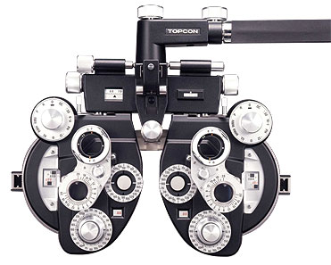 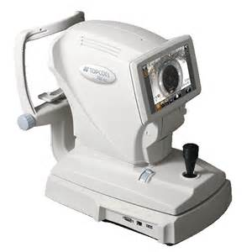

This necessary test tells your doctor a few important things about your vision.

1. Whether your vision complaints are caused by a medical disorder.
2. Your visual improvements following a surgical procedure.
3. Whether glasses or contact lenses would benefit your current visual state.

Medicare and most other insurance plans do not cover this test. The cost of a refraction is $45.00 and will be collected at the time of service. If you have any questions regarding this policy, please see one of our front office staff members.

By signing this form, you are acknowledging that you have read and understand the above policy.

This ***does not*** mean you are having a refraction today, it means that you understand the charge will apply should a refraction test be performed at any time.

Thank you for choosing St. Michael’s Eye & Laser Institute for your eye care needs. We look forward to caring for you.

______________________________________________________ ___________________

Patient or Responsible Party Date