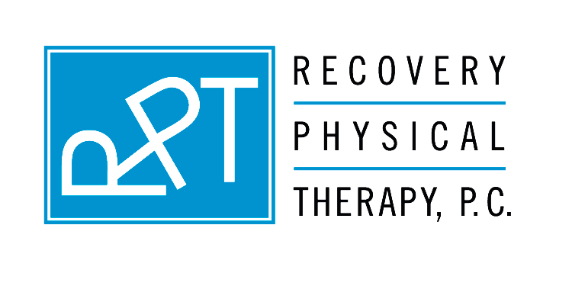
Send to: | From:
Attention: | Date:
Phone Number: | Total pages (including cover):
Fax number: | Regarding: Your intake paperwork

This message is intended for the use of the individual or entity to which it is addressed and may contain information that is privileged, confidential and exempt from disclosure under applicable law. If the reader of this message is not the intended recipient, employee or agent responsible for delivering this message to the intended recipient, you are hereby notified that any dissemination, distribution or copying of this communication is strictly prohibited. If you have received this communication in error, please notify us immediately by telephone, and return the original message to us at the above address via the U.S. Postal Service. Thank you.

The forms that you are required to complete prior to your initial evaluation will follow this page. Please read each form carefully, fill in all the requested information, as well as sign and date each page.

Please bring all of these completed forms with you to your initial evaluation appointment. If the forms are not completed prior to your appointment time it will detract from the time that your therapist will be able to spend evaluating and treating your condition.

Your initial evaluation is scheduled for: ___________, _________, _______ @ _______________.
day of week month year time of day (am/pm)

Please arrive promptly at least 20 minutes prior to the appointed time in order to process your paperwork and allow you sufficient time to change your clothing and lock up your belongings.

As a reminder, we request that (in addition to your completed paperwork) you bring the following:

-Your insurance card
-Driver’s license
-The original physician’s prescription for physical therapy
-Any MRI or x-ray reports you may have (these are recommended and not required).
-A lock to secure your belongings in a locker (for daily use only rather than for extended rental)
-Appropriate clothing– shorts and a tank or T-shirt are recommended
(Please do not wear sweat pants, tights or hose if we are to evaluate your back or lower extremities).

Note that you will not require sneakers for the first visit.

We look forward to meeting you!

